**Grondplan track Area**

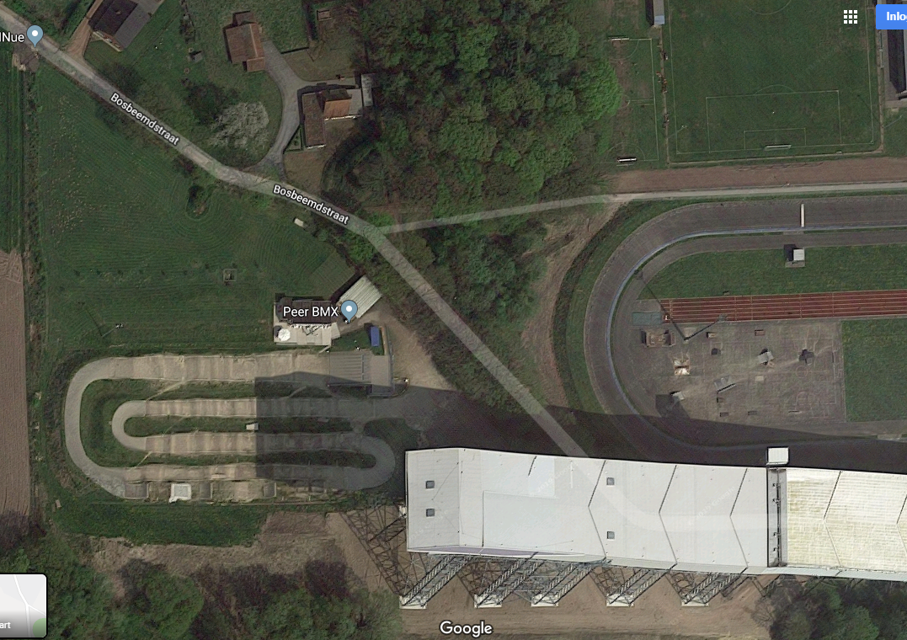

**Warm-up** zone

**Inkom**

**Officials**

**Vip**

**Food**

**Team Area**

**Team Area**

Bonnen

Drinks

**Stores**

**Parc Fermé 2**

WC

**P. F. 1**

EHBO